 Vol. 01, No. 01 (2024) 1-10, doi: XXXXXXXXXXXX - http://XXXXXXXXXXXX.aspur.rs
Global
Economic
Horizons

title

Name LastName¹ Received XXXXXX.
Name Last name Accepted XXXXXX.

Keywords: | A B S T R A C T
Keywords: | © 2024 Published by ASPUR
 | © 2024 Published by ASPUR

- INTRODUCTION

- literature review

- methodology

- Discussion and ANALYSIS

4.1 (if required)
4.2 (if required)

- Major Findings and Outcomes

- Conclusion

8.RECOMMENDATIONS FOR FUTURE WORKS

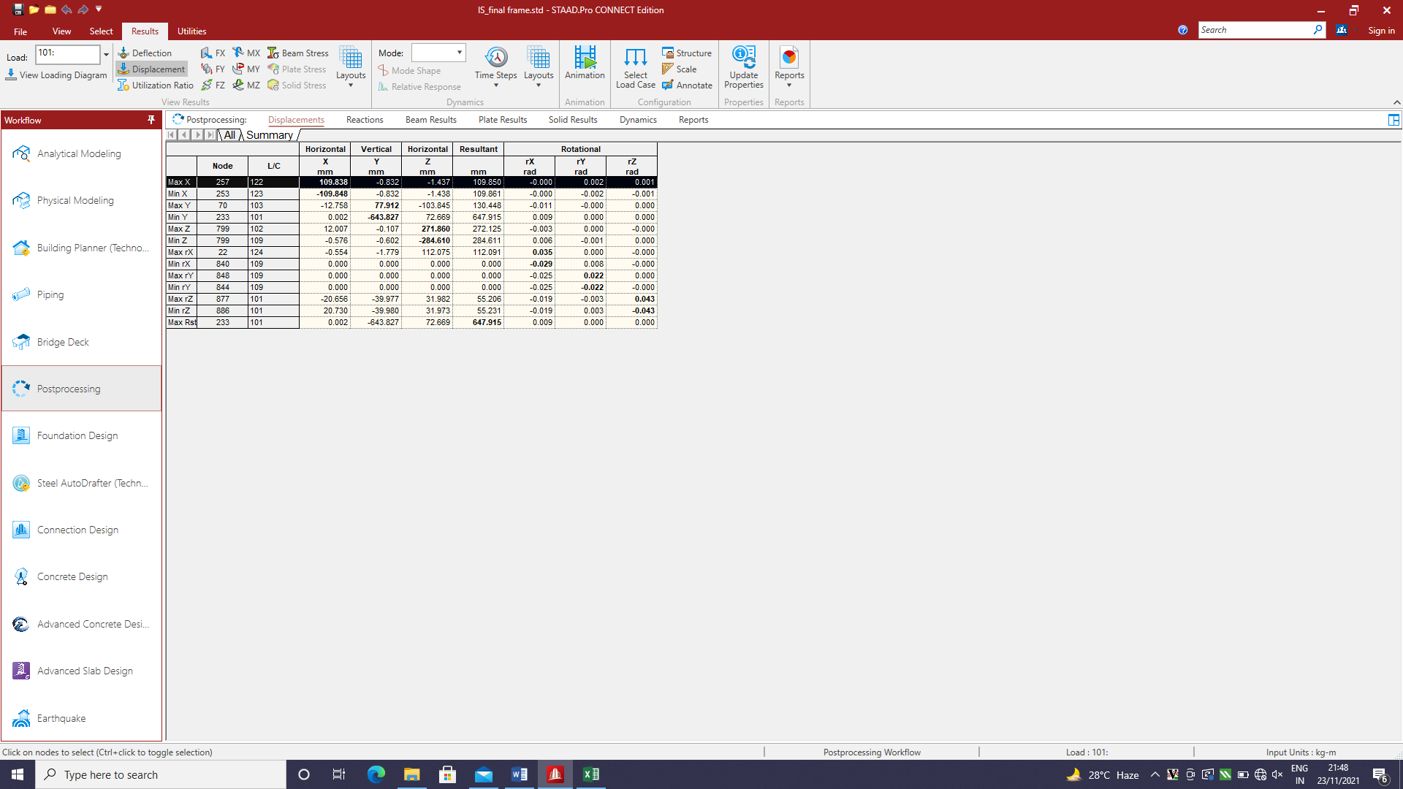
The below is the node displacement summary in the table form.

7. Suggestions

Analysis and design in this study yielded the following conclusions:

Acknowledgement: xxxxxxxxxxxxxxxxxxxxxxxxxxxxxxxxxxxxxxxxxxxxxxxxxxxxxxxxxxxxxxxxxxxxxxxxxxxxxxxxxxxxxxxxxxxxxxxxxxxxxxxxxxxxxxxxxxxxxxxxxxxxxxxxxxxxxxxxxxxxxxxxxxxxxxxxxxxxxxxxxxxxxxxxxxxxxxxxxxxx

References:

Animesh Tripathi., Rituraj., Shezad Meman.,& Nishant Patil.(2020). “ParametricStudy onDesign of Pre-Engineered building Using Is 800–2007 and AISC 360-10 13th Edition”, International Organization of Scientific Research (IOSR) Journal of Mechanical and Civil Engineering (IOSR-JMCE), Volume: 17, Issue: 4, page nos: 7 -14.
Anisha Goswami., Dr. Tushar Shende., Raisoni,G.H.(2018). “Pre-Engineered Building Design of an Industrial Warehouse”,International Research Journal of Engineering and Technology (IRJET), Volume: 05, Issue: 06, page nos: 1484 -1488.

Name Last name  Affilaition,  Country.  mail@mail.com  ORCID 0000-0000-0000-0000 | Name1 Last name1  Affilaition1,  Country1  Mail1@mail.com  ORCID 0000-0000-0000-0001

